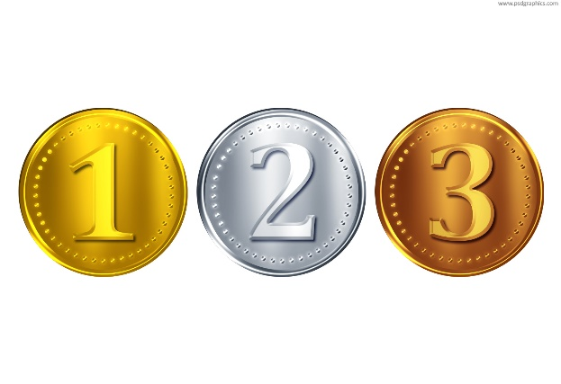BRONZE LEVEL TASKS

# Task – Input and print

Get a user to input their name

Say hello to the user

## Functions to use

[input](https://www.w3schools.com/python/ref_func_input.asp)

[print](https://www.w3schools.com/python/ref_func_print.asp)

## Save

Save your file as **inputandprint.py**

# Task – Add two numbers

Get the user to input a number

Get the user to input a second number

Add the 2 numbers together

Display the result on the screen

## Functions/Operators to use

[input](https://www.w3schools.com/python/ref_func_input.asp)

=

[print](https://www.w3schools.com/python/ref_func_print.asp)

## Save

Save your file as **addtwonumbers.py**

# Task – Running total

Get the user to input a number

Add the number to a running total

If the user enters E then exit the program and show the total

## Functions/Operators to use

[input](https://www.w3schools.com/python/ref_func_input.asp)

=

+

int

if

[print](https://www.w3schools.com/python/ref_func_print.asp)

## Save

Save your file as **runningtotal.py**

# Task – Area of a rectangle

Get the user to enter a **height**

Get the user to enter a **width**

Calculate the area of the rectangle given and display it to the screen

## Functions/Operators to use

[input](https://www.w3schools.com/python/ref_func_input.asp)

=

+

int

if

[print](https://www.w3schools.com/python/ref_func_print.asp)

## Save

Save your file as **areaofrectangle.py**

# Task – Volume of a cylinder

Get the user to enter a **height**

Get the user to enter a **radius**

Calculate the **volume** and display it.

## Functions/Operators to use

[input](https://www.w3schools.com/python/ref_func_input.asp)

=

+

[import](https://www.w3schools.com/python/python_modules.asp)

math.pi

int

if

[print](https://www.w3schools.com/python/ref_func_print.asp)

## Example Code

import math

print ("value of pi is ":math.pi)

## Save

Save your file as **volumeofcylinder.py**

# Task – Temperature converter

Find out how to convert Celsius to Centigrade and Centigrade to Celsius

Write a program that asks the user which **way** they want to convert

Get them to enter a value

Convert that based on the **way** that have wanted to convert and display it

## Save

Save your file as **tempconveter.py**

# Task – Circles

Get the user to input a **radius**

Calculate and print the **circumference**

Calculate and print the **area**

## Save

Save your file as **circles.py**